Q1.
Answer is C.

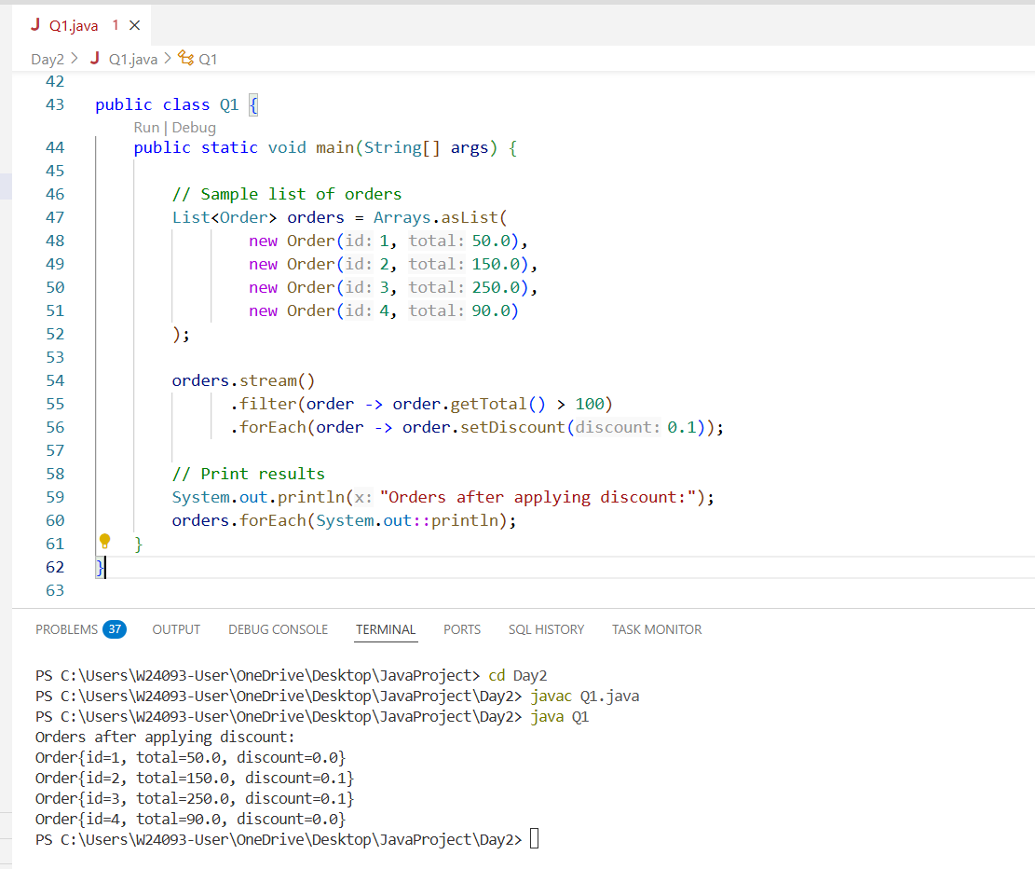

A: Incorrect. Missing filter conditions.

B: Incorrect. Misuse map(), won’t compile.

C: Correct.

D: Work but no Stream API.

Q2.
Answer is B.

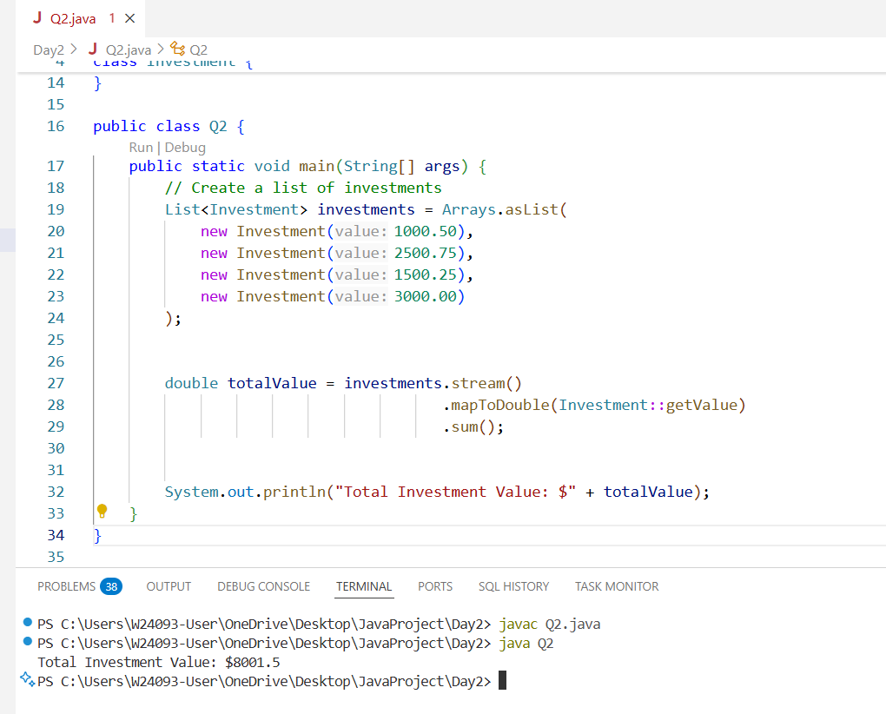

A: Incorrect. This code won’t compile.

B: Correct.

C: Also correct but complex.

D: Valid, but slower and more verbose than option B.

Q3.
Answer is A.

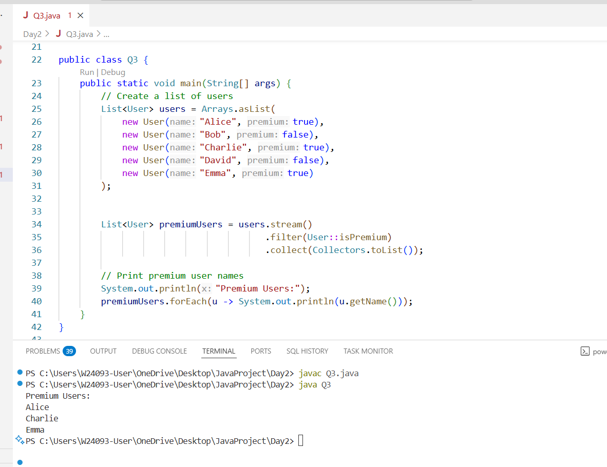

A: Correct.

B: Incorrect. Work correctly in java 16+.

C: Incorrect. Not efficient or clean.

D: Works but not efficient.

Q4.
Answer is A.

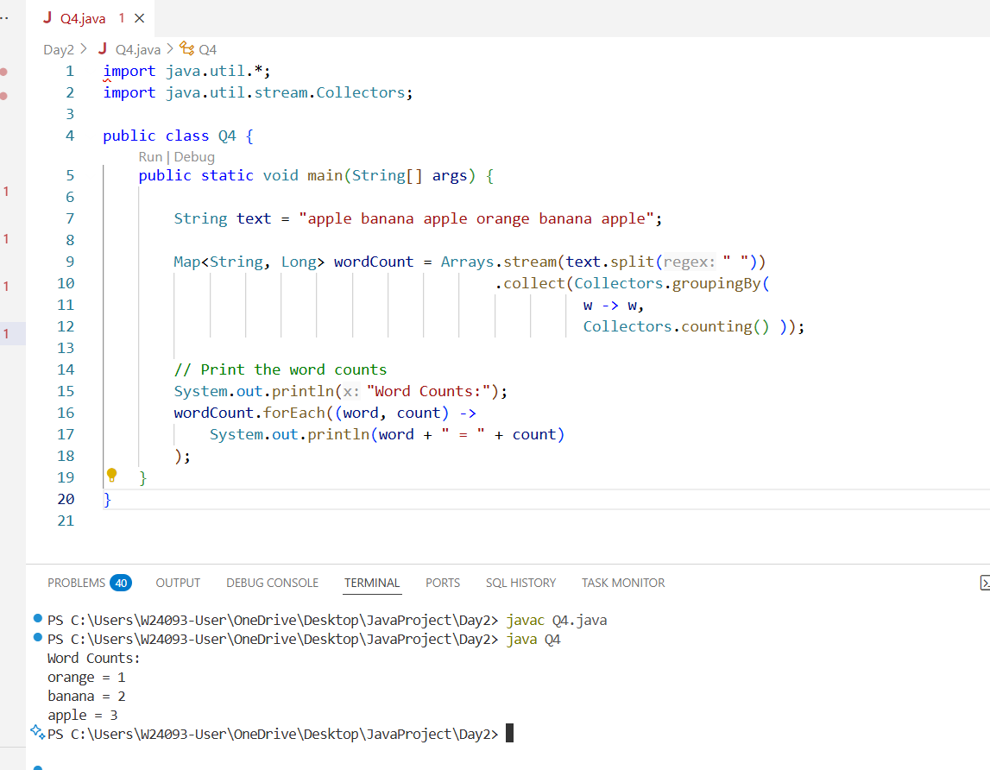

A: Correct compile and logic.

B: Incorrect. Work for small example.

C: Incorrect. It won’t compile.

D: Work but complex than A.

Q5.
Answer is A.

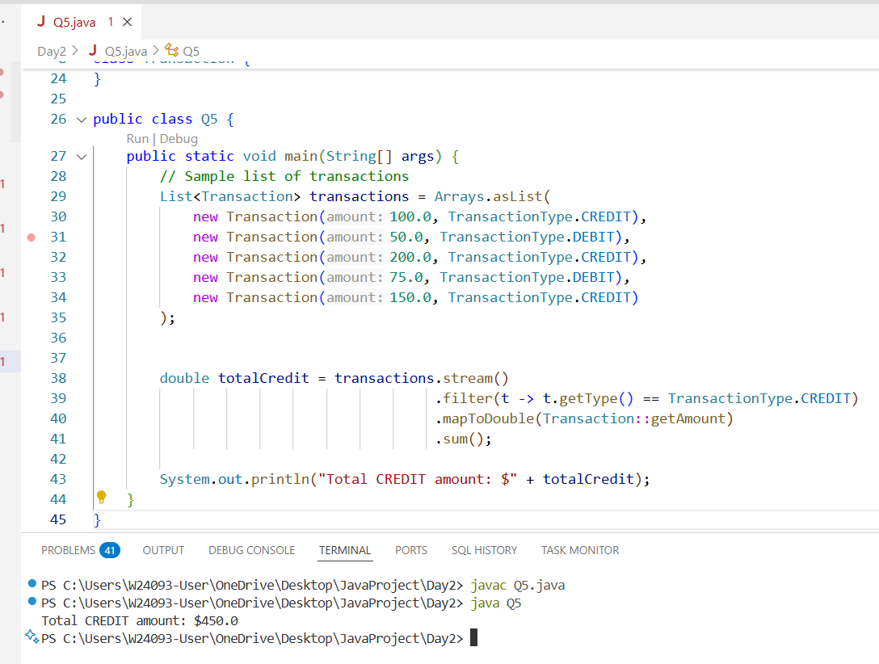

A: Correct. Clean and efficient.

B: Works but less efficient than option A.

C: more complex.

D: Equivalent to A, returns Double.

Q6.
Answer is D.

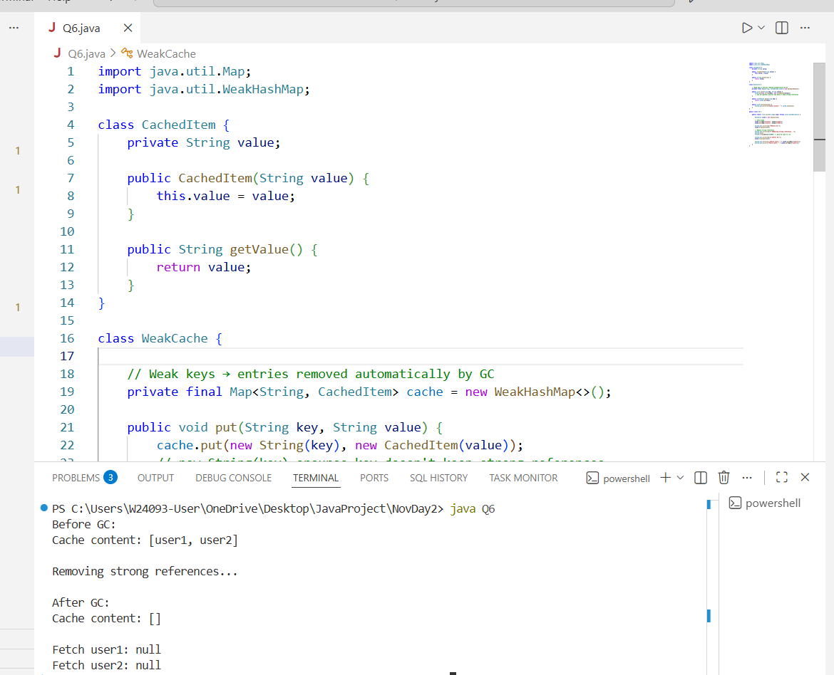

A: Basic key-value store. Does not automatically remove expired entries.

B: Thread-safe version of HashMap. Still doesn’t remove entries automatically.

C: Maintains insertion/access order. Can remove based on size, not time.

D: Best. Entries are automatically removed when keys are no longer referenced elsewhere. The garbage collector clears them.

Q7.
Answer is A.

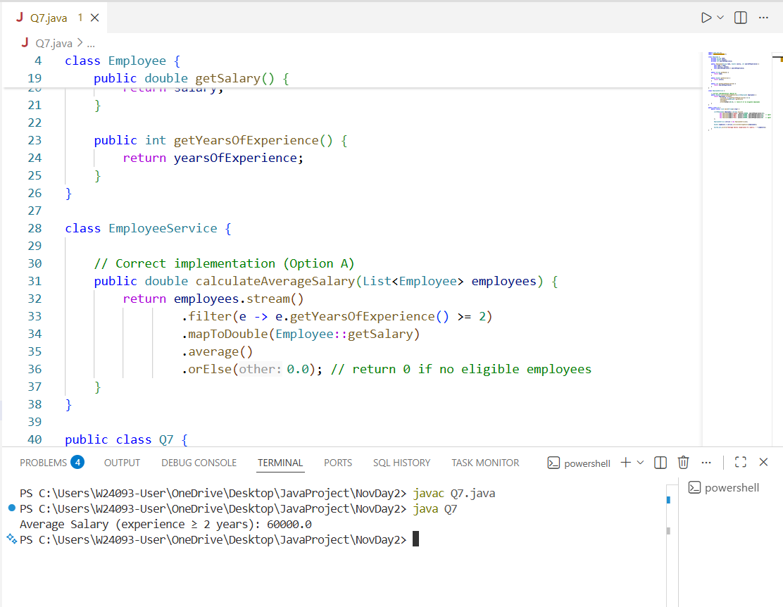

A: Correct. A uses the Stream API properly, applies OOP principles correctly.

B: Incorrect. Divides by all employees, not only filtered ones.

C: Incorrect. Not using Stream API.

D: Incorrect. Produces wrong average.

Q8.
Answer is A.

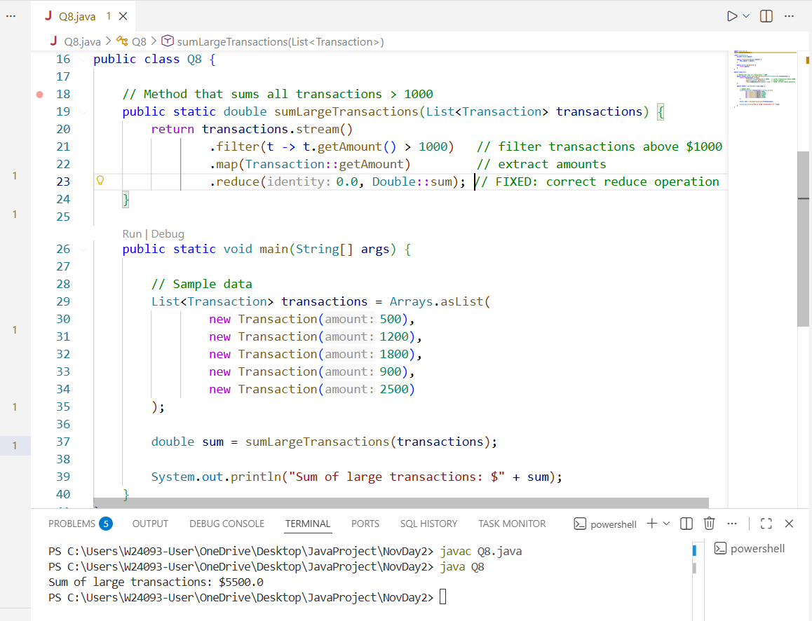

A: Correct answer.

B: Incorrect. The condition is already correct.

C: Incorrect. The issue is with reduce, not with “map” being unnecessary.

D: No need to convert amount to Double manually. This is unnecessary and not the cause of the problem.

